Eclipse Business Intelligence and Reporting Tools

Table of Contents

1. BIRT Installation 2

1.1 Approach I – Download eclipse with preinstalled BIRT designer plugin 2

1.3 Approach II – Add plugin to existing Eclipse 2

2. Designing Reports 3

2.1 Creating a new report 3

2.2 Adding a Data Source 3

2.3 Adding Data Set 5

2.4 Editing Data Set 6

2.4.1 *Output columns* 6

*2.4.2* *Computed Columns* 7

*2.4.3* *Parameters* 8

*2.4.4* *Filters* 10

*2.4.5* *Preview Results* 10

2.5 Creating Template 10

*2.5.1* *Directly right-click on designer and add new elements* 11

*2.5.2* *From ‘Outline’ view* 11

*2.5.3* *Drag-n-drop from ‘Palette’ view* 12

*2.5.4* *Other features* 12

3. Deploying Reports 16

3.1 Introduction to BIRT Engine 16

3.2 Integrating BIRT with Spring Boot 16

*3.2.1* *POM* 16

*3.2.2* *Resource Handlers* 17

*3.2.3* *BIRT Service* 17

*3.2.4* *BIRT Controller* 18

## BIRT Installation

### Approach I – Download eclipse with preinstalled BIRT designer plugin

* + - Maintain a separate eclipse installation for BIRT instead of adding plugin to existing eclipse version to keep it simple. Also note that not all eclipse versions support BIRT package and some work with specific version and might end up with version compatibility issues

<https://www.eclipse.org/downloads/download.php?file=/birt/downloads/drops/R-R1-4.8.0-201806261756/birt-report-designer-all-in-one-4.8.0-20180626-win32.win32.x86_64.zip>

### Approach II – Add plugin to existing Eclipse

* + - Go to <https://wiki.eclipse.org/BIRT_Update_Site_URL> to choose site url
    - Go to Eclipse Window -> Install new software

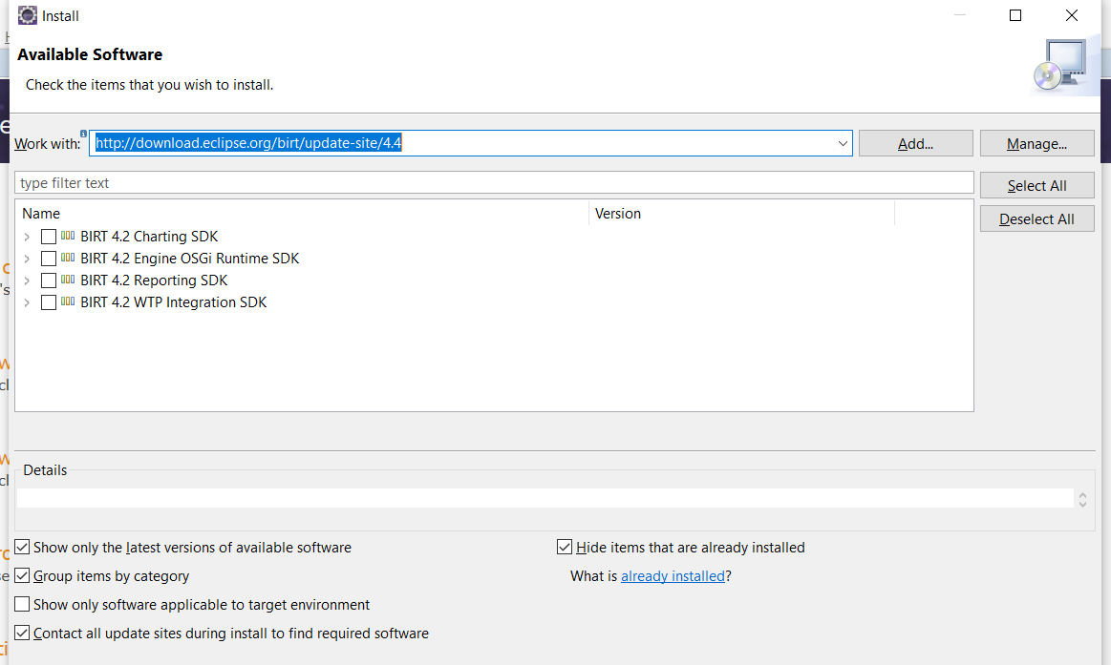

* + - Select all the software items and complete the installation
    - Trust the certification and continue

## Designing Reports



### Creating a new report

* + - Go to File->New->Report. Enter name and click ‘Finish’ unless there is requirement for any standard templates
    - Open the newly created report in ‘Report Designer’ perspective

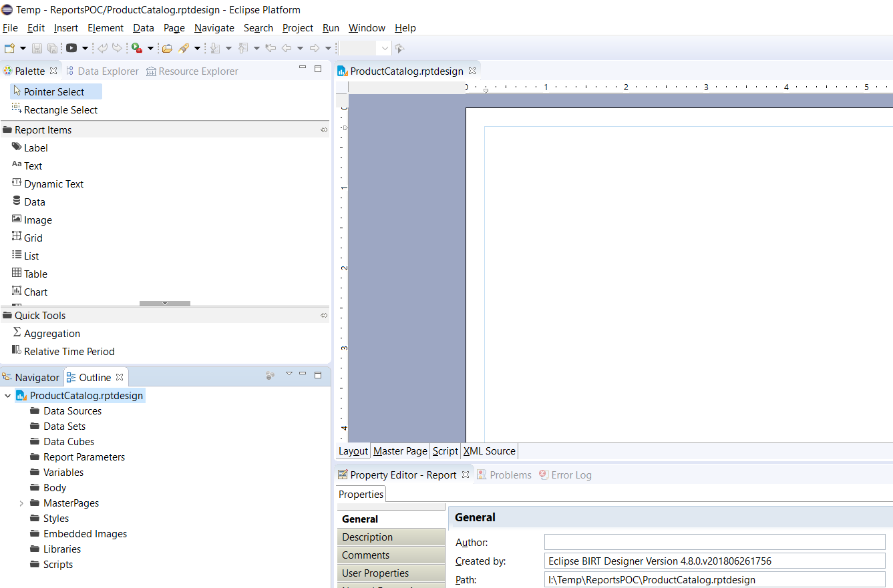

### Adding a Data Source

* + - Go to ‘Outline’ view of the report and right-click on ‘Data sources’. Select new datasource option
    - Select the datasource type from the opened dialog window (in this documentation MySQL datasource will be created)

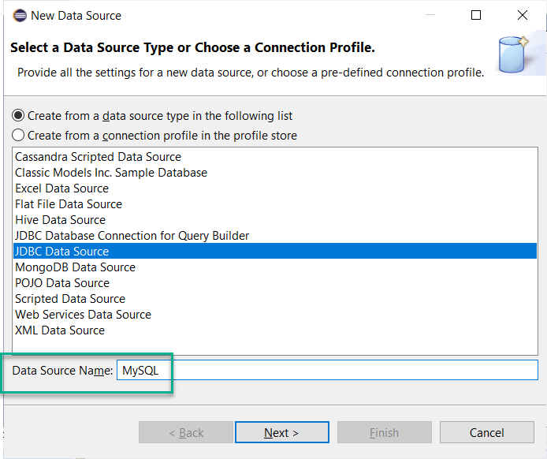

* + - In the next window, click on ‘Manage Drivers’. Add mysql-connector.jar to add driver class

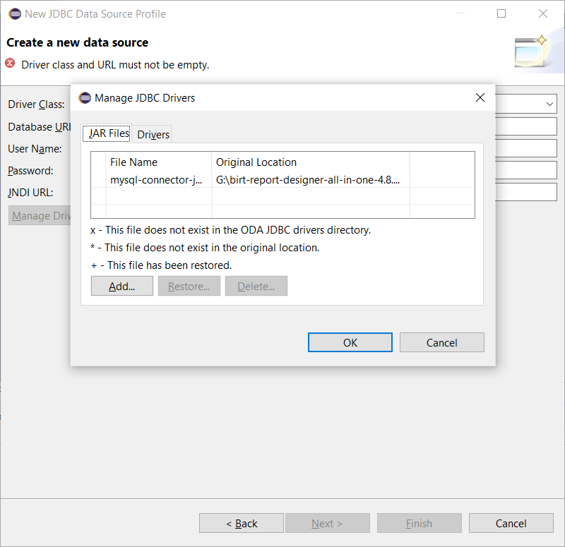

* + - Add the mysql database details as shown below and click ‘Finish’

**Note that the database url can be appended with schema to work with specific schema (shown in second screenshot)**

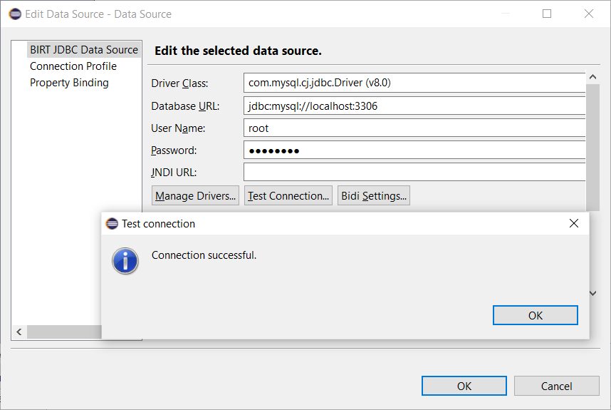

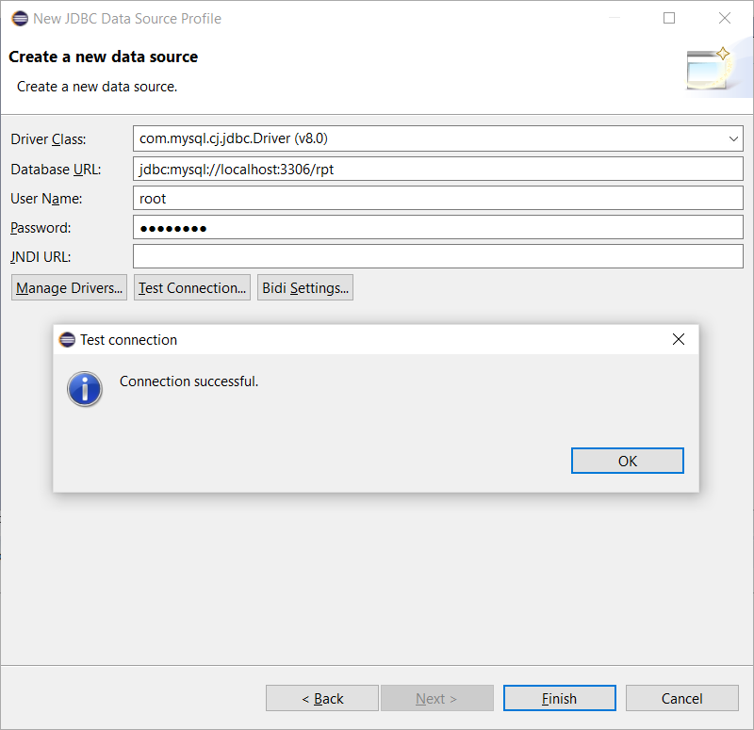

### Adding Data Set

* + - Right-click on ‘Data Sets’ and add ‘New Data Set’
    - Select Data Source in next window and also choose to build the data set with SQL query or Stored procedure (in this documentation ‘SQL query’ is used)
    - Enter Data Set name and click ‘Next’

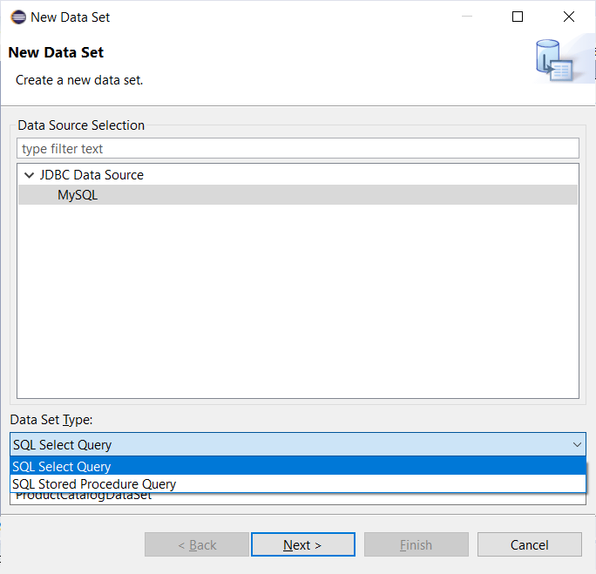

* + - Database schema items can be filtered in next widget as shown in below screenshot

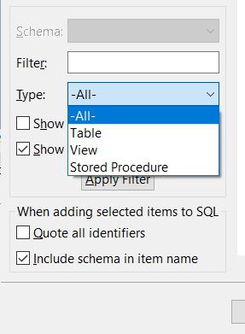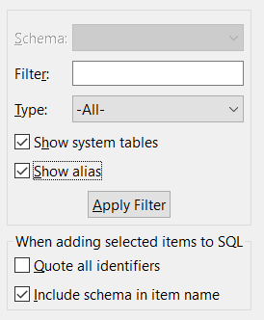

* + - The query can be created by drag-n-drop feature (pulling database items into editable area)

**Note1:** Can write query with multiple schemas using schema name manually while writing query (or) check the box ‘Include schema in item name’ while drag-n-drop

**Note2:** Complex queries with joins or aggregations can be written here or it can be handled with BIRT features as well

In this documentation a simple query is built for listing product catalogue

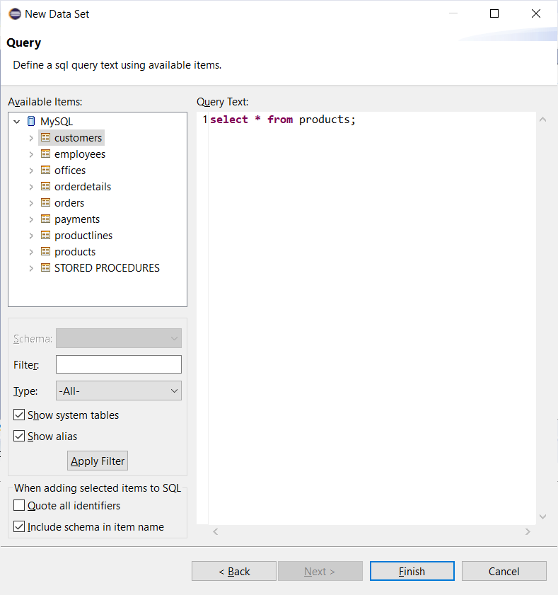

* + - On clicking ‘Finish’, ‘Edit Data Set’ dialog will be opened

### Editing Data Set

### Output columns

These can be configured as shown below by clicking ‘Edit’ button

Name – DB column name

Type – Data type of the column

Alias – DB column name Alias (can be handled in select query or can be handled here)

Display Name – Display Name of the DB column

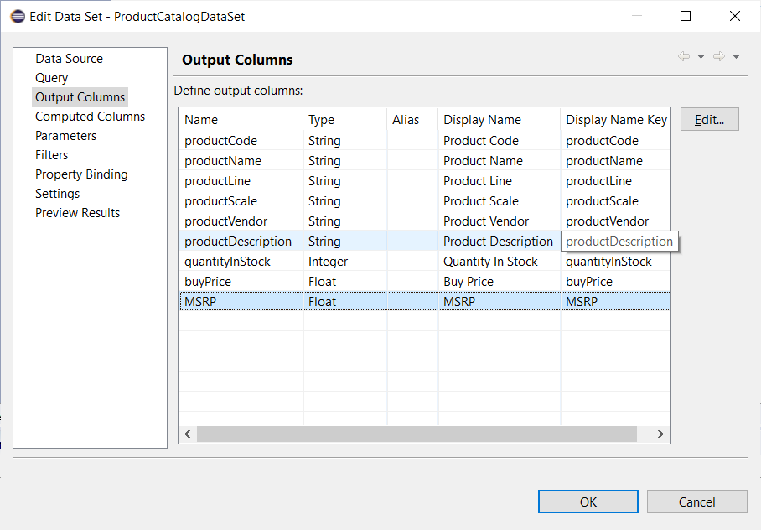

### Computed Columns

Additional columns can be derived based on Database columns. Plenty of native JavaScript, BIRT functions and Operators are available to create useful expressions

Click on ‘New’ button from ‘Computed Columns’ window and enter details for computed column

Then, click on ‘fx’ to create Expression

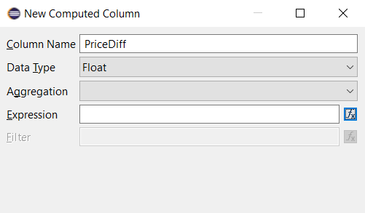

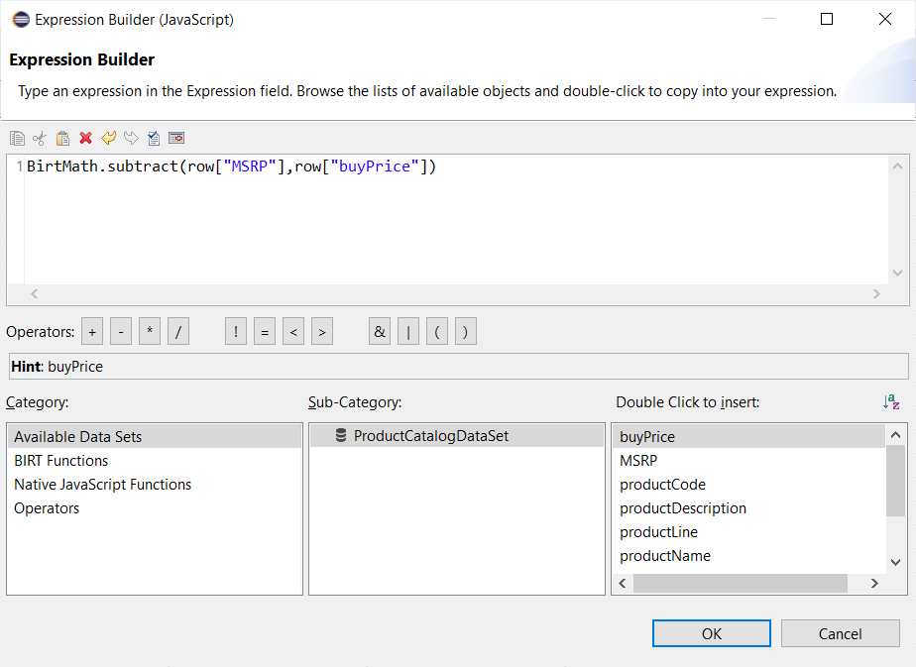

### Parameters

The select queries can be written including query params. The data for query params cab be configured here. There must be a one-to-one correspondence between entries on this page and the "?" symbols in your query

**Example:**

Scenario – Retrieve products by product line like cars, trains, ships etc.

1. Configure select query to include query param like below:

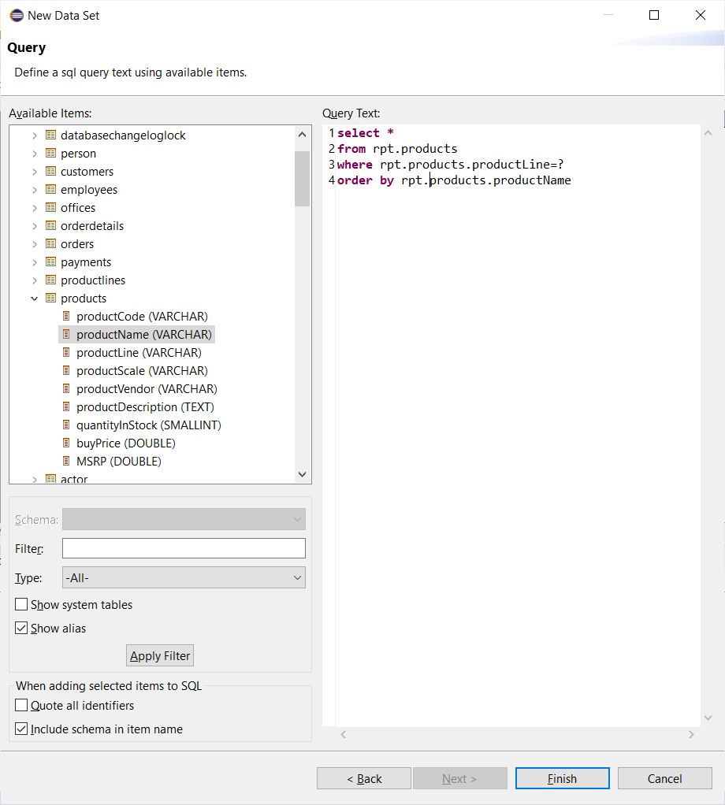

1. Then go to ‘Parameters’->click ‘New’ and below dialog opens up

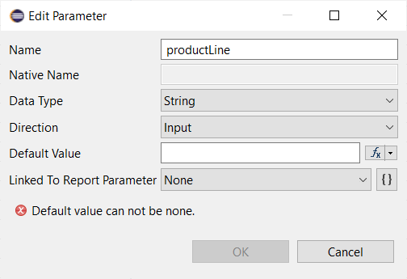

1. Then, create new parameter by clicking on ‘{}’ button from above screenshot

There are four types of input fields that can be added in the report

* Text box
* Combo box
* List box
* Radio button

Also, there are two ways to populate the values in the input fields

* Static
* Dynamic

1. Database columns can be configured into the input field values as shown in below screenshot

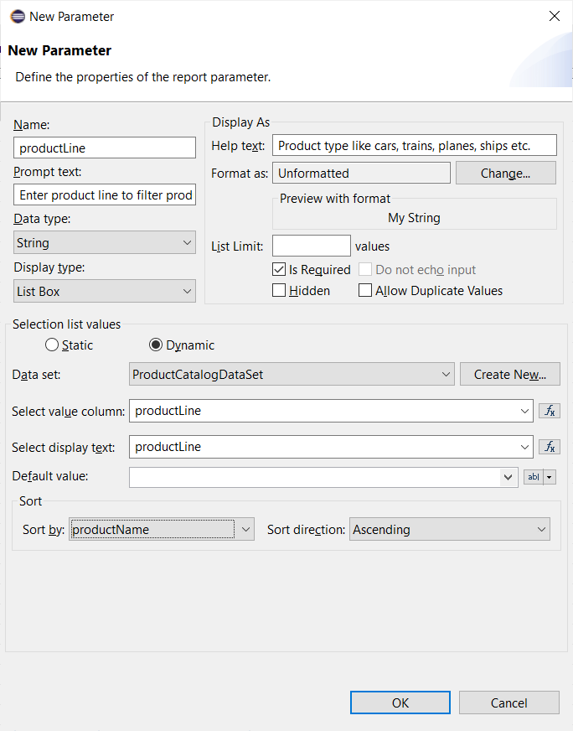

1. Below input field will be shown when the report is opened or accessed

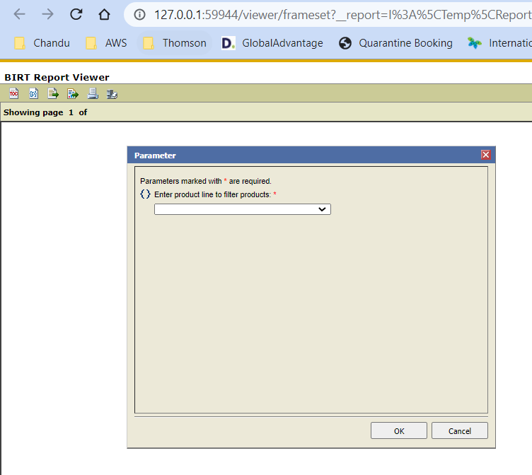

### Filters

All filtering can be done from SQL select query. But BIRT also provides additional layer of filtering to restrict the data shown on the report using JavaScript. This enables not just filtering by value but based on certain logic as well

### Preview Results

The data set & other configurations created can be tested in this section. Note that preview cannot be seen if there are query params configured for select query.  
  
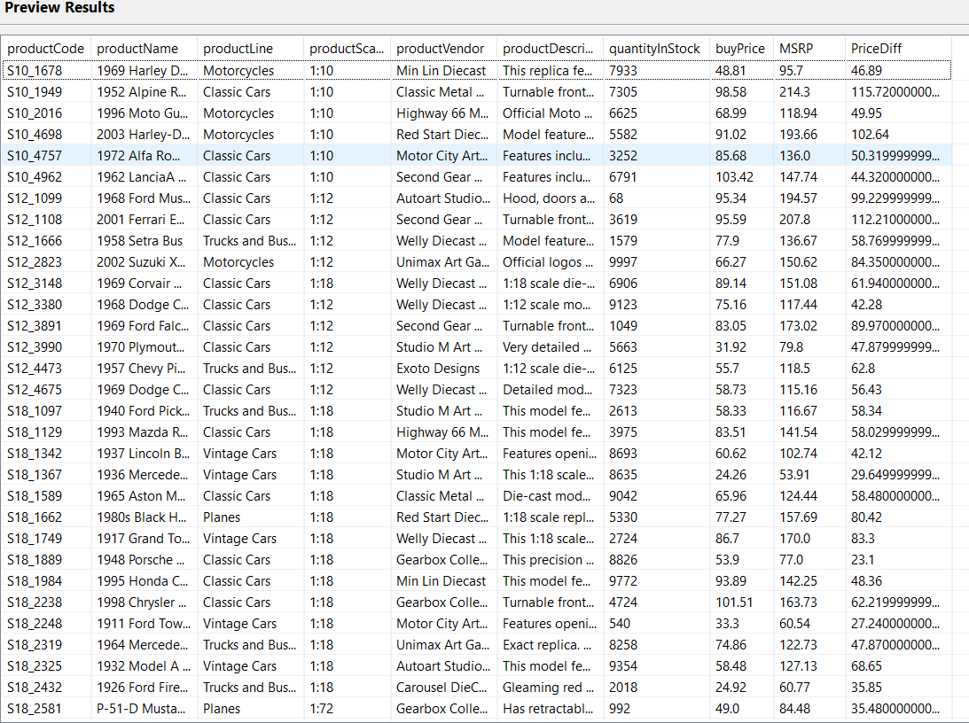

### Creating Template

The report is structured like an HTML page, with header, body, footer, scripts, and styles.

The framework provides an extensive set of components to choose from out-of-the-box, including integration to mainstream data sources, layouts, charts, and tables. And, we can extend it to add our own!

Elements can be inserted in the report in three different ways

* + - Directly right-click on designer and add new elements
    - From ‘Outline’ view
    - Drag-n-drop from ‘Palette’ view

List of Elements:

Label, Text, Dynamic Text, Data, Image, Grid, List, Table, Chart, Cross Tab

### Directly right-click on designer and add new elements

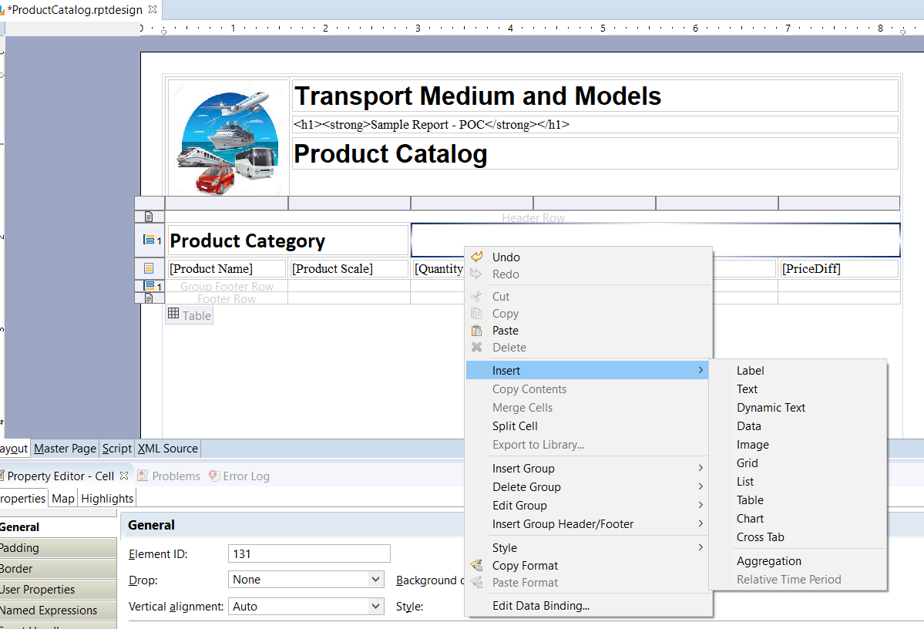

### From ‘Outline’ view

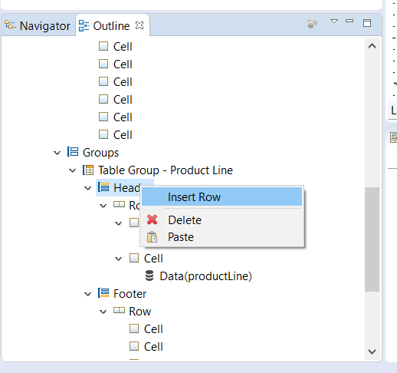Go to ‘Outline’ of the report->right-click on ‘body’->click on ‘insert new element’

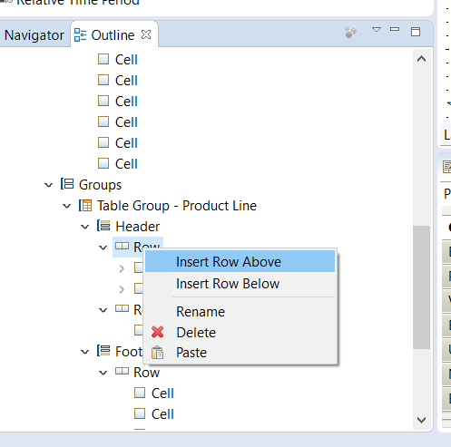

### Drag-n-drop from ‘Palette’ view

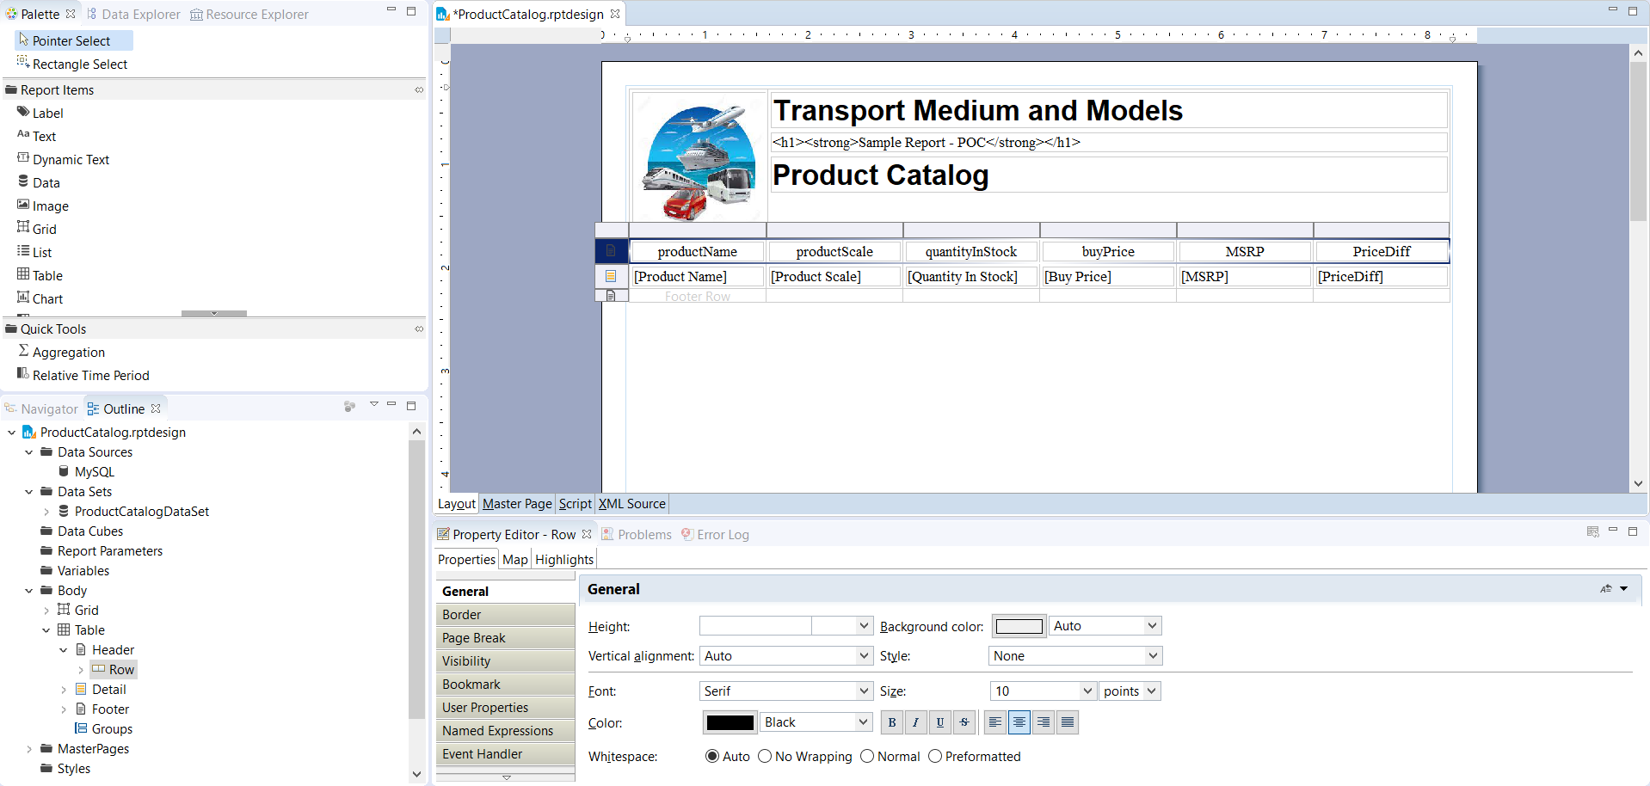

**Tip:** Insertion of elements from ‘Outline’ view of the report is recommended and easy to add/modify

### Other features

**Data binding to a field/element:**

Right-click on any element -> click on ‘Edit Data Binding’->select ‘Data Set’->Add required Data columns

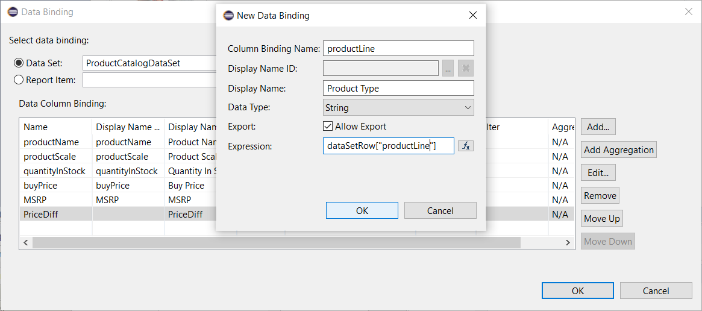

**Operations on cells:**

Similar operations that are available in an excel are available in BIRT designer as show below

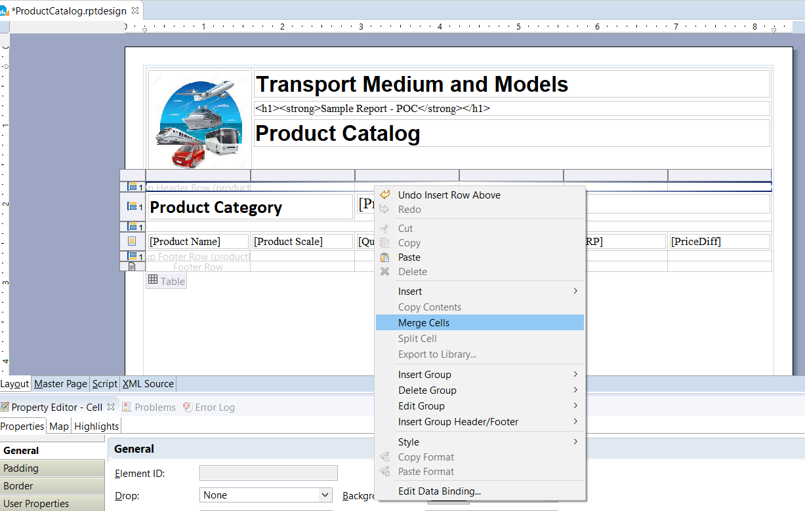

**HTML code rendering:**

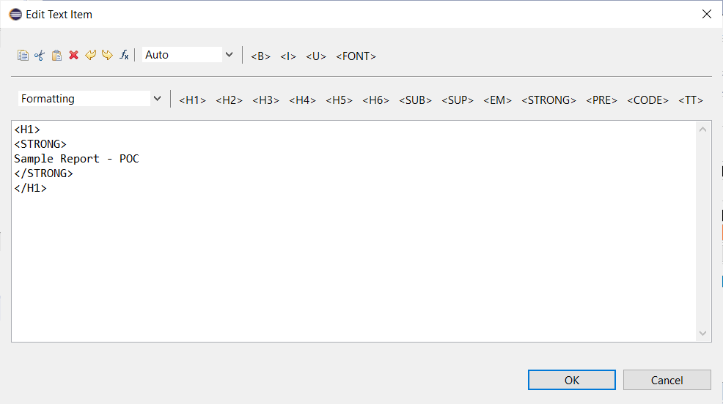

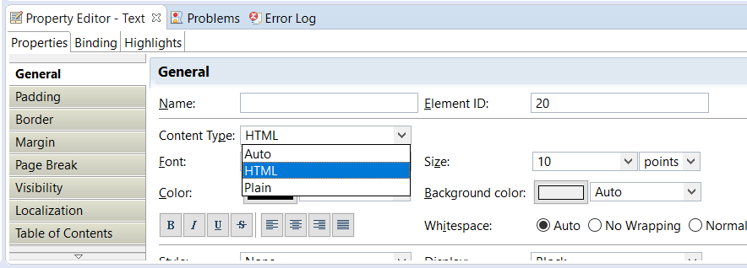

**Element Styling:**

Fonts, Font size, Color, Background color and other styling can be configured as shown below

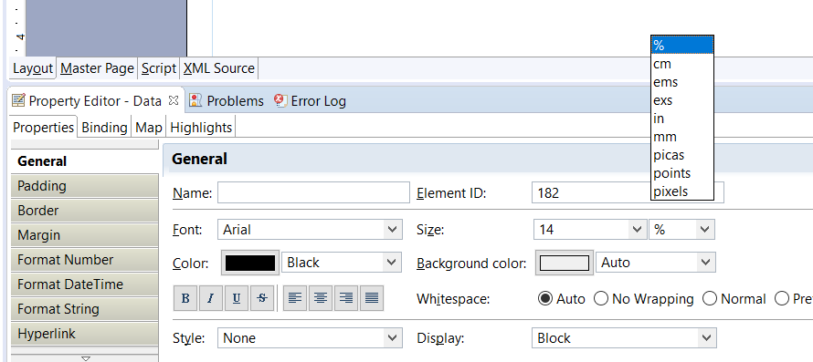

Multiple fields can be edited at one time by selecting them from ‘Outline’ view

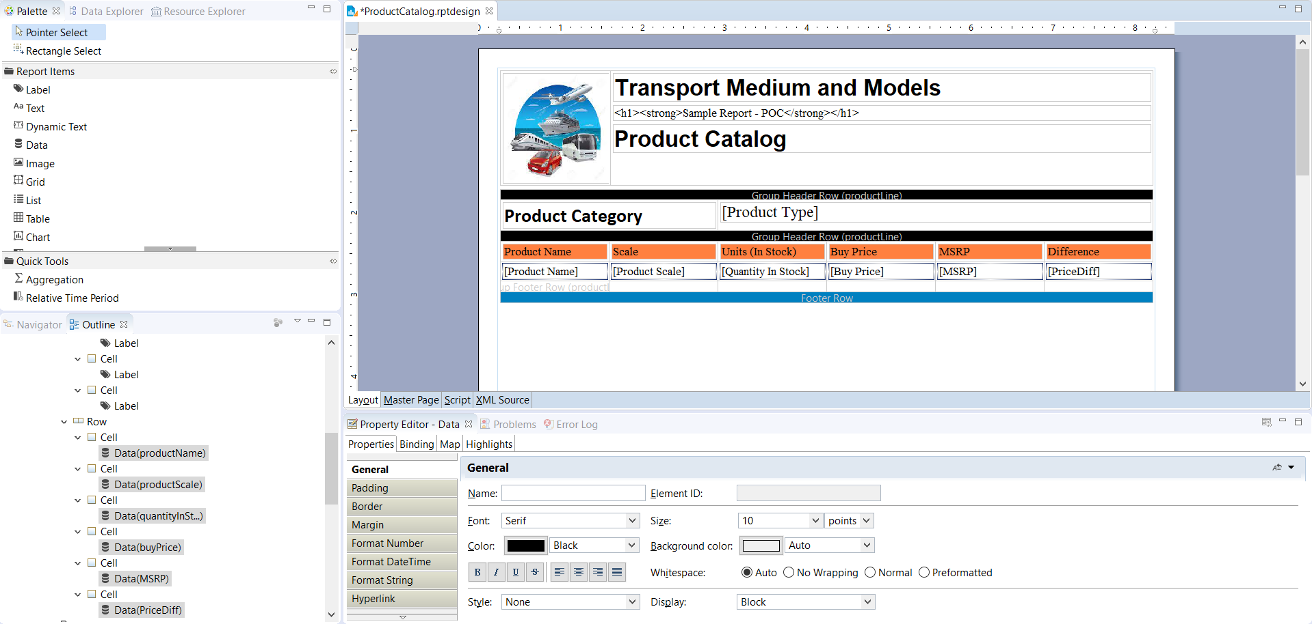

**Embedding JavaScript:**

JavaScript code can be embedded by adding a text element and configuring the content type as HTML

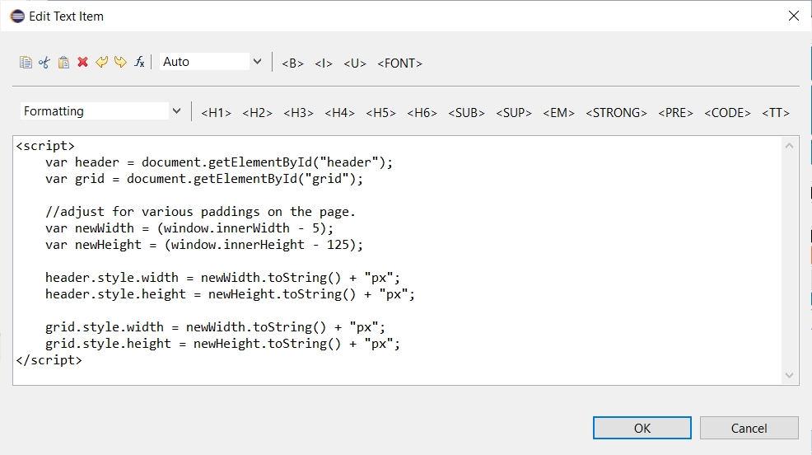

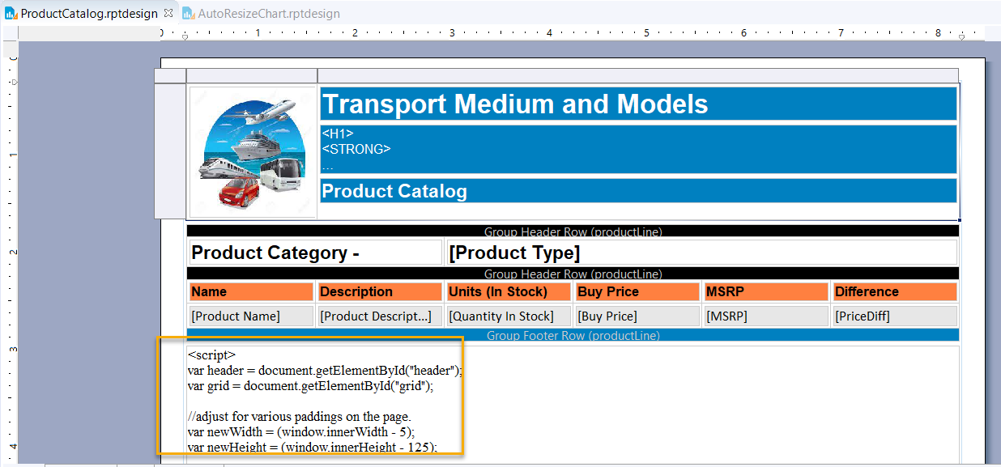

**Page layout configuration:**

We have lots of configuration available to customize the design. Below are few examples of adjusting width, height of the page and layout orientation

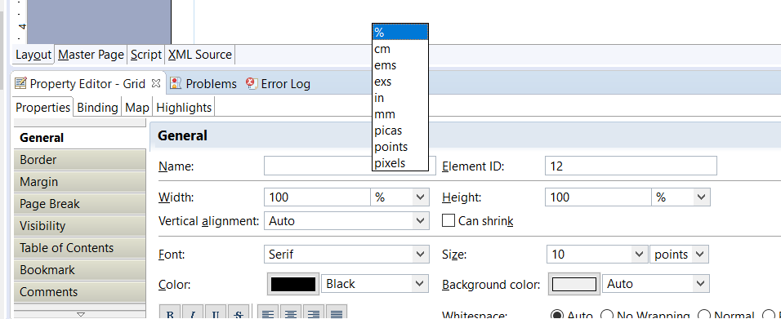

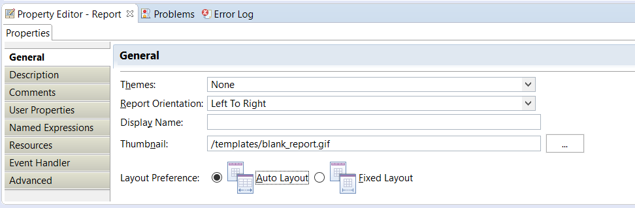

## Deploying Reports

Data visualization reports created in BIRT can be integrated into Java web applications. BIRT has two main components: visual report designer to create report design files, and runtime component for interpreting and rendering those designs.

We will be utilizing runtime component as the reports are created in Eclipse which is preinstalled BIRT plugin/designer.

In the BIRT framework, a report is nothing but a **XML configuration** file, identified by the extension rptdesign. It tells the Engine what to draw and where, from the style of an element to the required properties to connect to a data source.



### Introduction to BIRT Engine

The ReportEngine class, which interprets the design files and generates the final result, is part of the BIRT runtime library.

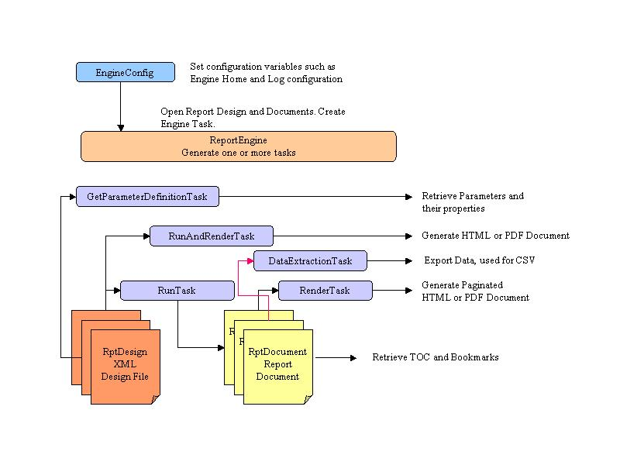

### Integrating BIRT with Spring Boot

### POM

Add below dependencies to the pom.xml to configure BIRT, Log framework and MySQL

<dependency>  
 <groupId>com.innoventsolutions.birt.runtime</groupId>  
 <artifactId>org.eclipse.birt.runtime_4.8.0-20180626</artifactId>  
 <version>${eclipse.birt.runtime.version}</version>  
</dependency>  
<dependency>  
 <groupId>log4j</groupId>  
 <artifactId>log4j</artifactId>  
 <version>${log4j.version}</version>  
</dependency>  
<dependency>  
 <groupId>mysql</groupId>  
 <artifactId>mysql-connector-java</artifactId>  
 <version>${mysql.connector}</version>  
</dependency>

Since BIRT works with Log4J, we need to exclude logback from starter logging

<dependency>  
 <groupId>org.springframework.boot</groupId>  
 <artifactId>spring-boot-starter-logging</artifactId>  
 <exclusions>  
 <exclusion>  
 <groupId>ch.qos.logback</groupId>  
 <artifactId>logback-classic</artifactId>  
 </exclusion>  
 </exclusions>  
</dependency>

Add below properties and dependency versions

<properties>  
 <start-class>com.birt.engine.ReportEngineApplication</start-class>  
 <maven.compiler.source>1.8</maven.compiler.source>  
 <maven.compiler.target>1.8</maven.compiler.target>  
 <eclipse.birt.runtime.version>4.8.0</eclipse.birt.runtime.version>  
 <log4j.version>1.2.17</log4j.version>  
 <mysql.connector>8.0.26</mysql.connector>  
</properties>

### Resource Handlers

Configure resource handlers for BIRT reports and images folder in SpringBoot Starter Application class

|  |
| --- |
| @SpringBootApplication @EnableWebMvc public class ReportEngineApplication implements WebMvcConfigurer {  @Value("${reports.relative.path}")  private String reportsPath;  @Value("${images.relative.path}")  private String imagesPath;   public static void main(final String[] args) {  SpringApplication.*run*(ReportEngineApplication.class, args);  }   @Override  public void addResourceHandlers(ResourceHandlerRegistry registry) {  registry  .addResourceHandler(reportsPath + imagesPath + "/**")  .addResourceLocations("file:///" + System.*getProperty*("user.dir") + "/" + reportsPath + imagesPath);  }  } |

### BIRT Service

initialize() – To create BIRT engine and load reports

getReports() – To fetch the list of reports deployed

generateMainReport(String reportName, OutputType output, HttpServletResponse response, HttpServletRequest request) – To generate report based on output type (HTML/PDF)

### BIRT Controller

Below are the list of service methods created to retrieve list of reports deployed, reload the reports from disk and view reports in HTML/PDF content type

1. listReports –

url: <http://localhost:8080/reports>

Response:

|  |
| --- |
| [  {  "title":"Product Catalog Report",  "name":"ProductCatalog",  "parameters":null  }  ] |

1. reloadReports –

url: <http://localhost:8080/reports/reload>

Response: “success”

1. generateFullReport –

url: <http://localhost:8080/report/ProductCatalog?output=html>

Response:

